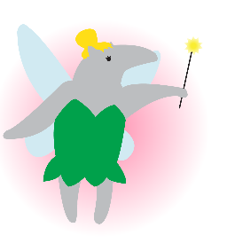

Presenting…  
**Circle K International**

**at UC Irvine**

2012 Fall Quarter, Wk 4

Tuesday, October 23, 2012

www.ucicirclek.org

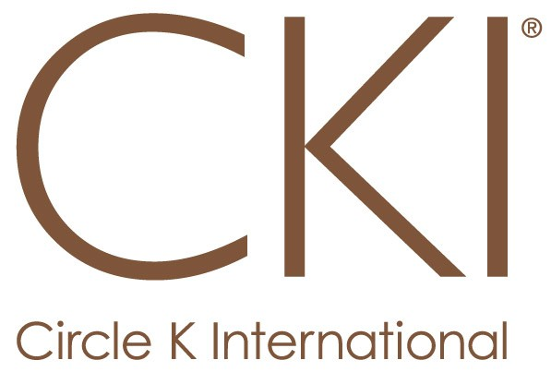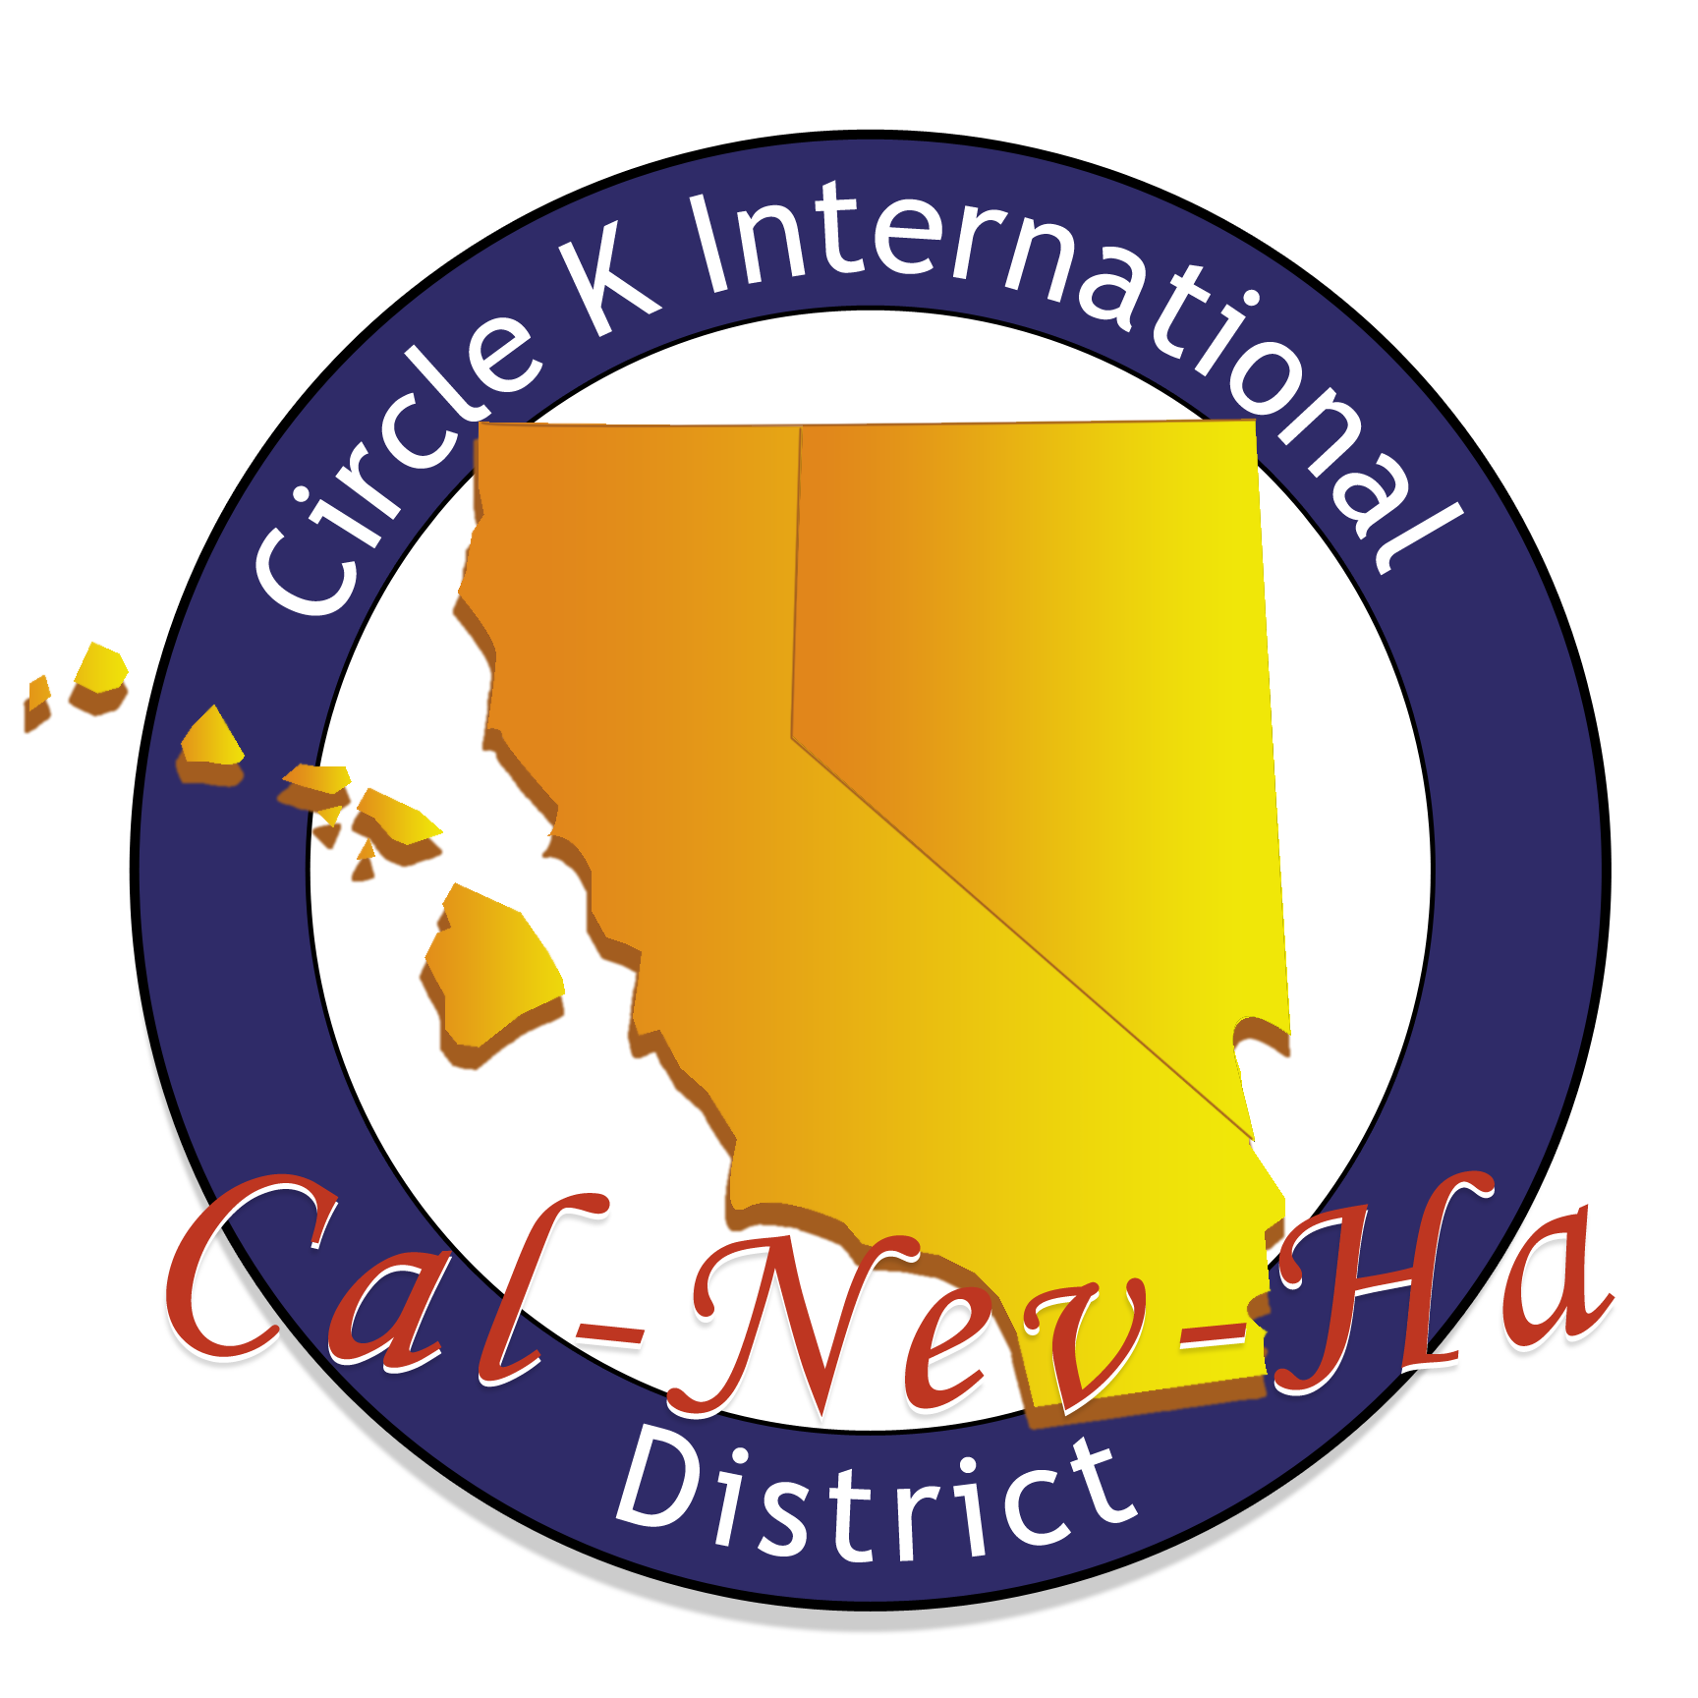

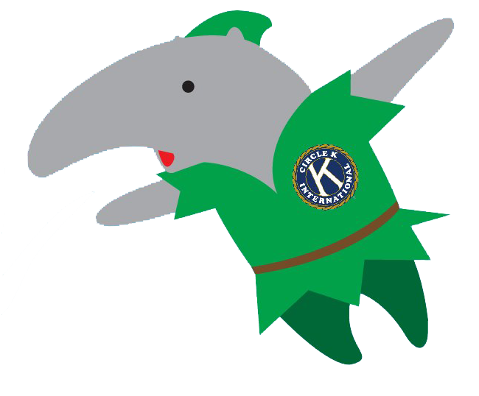

## October 2012

|  |  |  |  |  |  |  |  |
| --- | --- | --- | --- | --- | --- | --- | --- |
|  | TUES. Oct. 23 | WED. Oct. 24 | THURS. Oct 25 | FRI. Oct 26 | SAT. Oct. 27 | SUN. Oct 28 | MON. Oct. 29 |
| SERVICE |  | -**Working Wardrobe** @2:50-5pm | -**Book Doctor** @ 3:30-5:30pm | -**Hemopet** @ 8:30-11am  -**Pumpkin Craving w/ OC Zoo** @8:30am-12:30pm | -**Roots Project** @8:30am-12:30pm |  | -**THINK Together** @ 2:50-5:00pm  -**Apron Project Pt. 2** @6-7pm in SSL 228 |
| LEADERSHIP | -**Irvine Kiwanis** @ 7-9am  **-Tabling** @10am-2pm on ring road  -**Whittier CKI Mtg** @ 3:15pm  -**OCC CKI Mtg** @ 4pm  -**UCI CKI Mtg @** 6pm | -**Spirit/Social Committee Mtg** @8-9pm in HH 142 | **-CDM Kiwanis Mtg** @ 11:30am-1:50pm  -**FV Kiwanis Mtg** @ 11:45am-1:30pm  -**IVC CKI Mtg** @ 2:30pm -**SAC CKI Mtg** @ 2:30pm  -**CSUF CKI Mtg** @ 5pm  -**Tech Committee Mtg** @6-7pm in HH 224 | -**Lake Forest Kiwanis Mtg** @ 6:40-9am |  | -**Board Meeting** @6pm | **-Saddleback Kiwanis** **Mtg** @ 11am-2:15pm  -**Fundraising Committee Mtg**  @ 5-6pm in SSL 228 |
| FELLOWSHIP | **-Scavenger Hunt Social** @ 8pm | **-Coffee Time w/ Sarina** @ 11-1pm |  | -**SAC CKI Fundraiser** @ Dairy Queen ALL DAY!  -**Magic Kingdom Spirit Night** @ 7-8:30pm at Dairy Queen | -**FAMILY DAY @** 12pm-5pm |  |  |

**Lollicup Battle of the Clubs Fundraiser:** NOW until January 31st!

**UPCOMING**

**EVENTS**

**UCI EVENTS:** Family Day 10/27 || TV Taping Fundraiser 11/09

**DIVISIONAL EVENT:** Spirit Night 10/26 || UCSD ‘s Masquerade Ball 11/10 [$30 admission]

**DISTRICT EVENTS**: Fall Training Conference (FTC) – 11/2-11/4

Week 4: RH 104

Week 5 & 6: Doheny Beach A  
Week 7: Pacific Ballroom C

Week 8: Pacific Ballroom D

Week 9: RH 104

**Website:** www.ucicirclek.org  
**Facebook:** http://www.facebook.com/groups/242970149059638/  
**Tumblr:** http://ucicki.tumblr.com/  
**Flickr:** http://www.flickr.com/photos/ucicirclek  
**Newsletter:** http://issuu.com/adrianfrancisco

**GET CONNECTED**

**Gen. Mtg Locations**

**REMINDERS**

* **Member Application?** Ask a board member or download one from our website: [www.ucicirclek.org](http://www.ucicirclek.org)
* **Drop off Dues/App.** during Gen. Mtg, to any board member, or at Phoenix Grill Tues-Thurs @ 2-3pm to Elmore, Treasurer.
* Click on an event you like on the calendar and **sign up online to attend**: <http://clubs.uci.edu/circlek/SSB_calendar.php>
* **Need a ride to an event?!?!** Meet at the flagpoles for ALL events!
* **Want to chair an event?** Add your name and number on our Chair Doc: <https://docs.google.com/spreadsheet/ccc?key=0AnKaL6lqusFSdFhvbWNYNklING42UEpNSHVCTk9CZ1E&authkey=CICZjZED&authkey=CICZjZED>
* **Want to Submit an Article for “The Second Star?”** Contact our Bulletin Chair, Adrian Francisco!
* **Lollicup Battle of Clubs Fundraiser:** Mention that you are in CKI and we will be closer to winning $500 for charity!
* **CHEER VIDEO COMPETITION** EXTENDED until further notice!

**Agenda**

* **Call to Order – Sarina Saldana, President**
* **Introduction of Guests – Sarina Saldana, President**
* **Upcoming Service Events – Amy Hoang**
* **Bulletin – Adrian Francisco**
* **Fundraising – Connie Phan & Ryan Leung**
* **K-Family – John Delshadi & Samia Chowdhury**
* **MD&E – Liz Ly**
* **Shoutout Box – Adrian Francisco**
* **MRP – Tanya Luu**
* **PR – Charmaine Deomampo & Nathan Magtoto**
* **Scrapbook – Kevin Lam**
* **Single Service – Michelle Ha & Samantha Ho**
* **Spirit/Social – Lany Dao & Sam Barke**
* **Technology – Brian Chew**
* **VPA – Mayra Escobar**
* **Secretary – Karen Truong**
* **Treasurer – Elmore Villaruel**
* **President – Sarina Saldana**
* **Meeting Adjourned – Sarina Saldana, President**

**BUY THIS DIVISIONAL SHIRT FOR ONLY $10!** Give your money to our President, Sarina Saldana or LTG, Stephanie Nguyen!

**FAMILY DAY**

10.27.12 ||| 12pm-5pm

*Let the games BEGIN…*

